Discover St. Louis (Education)  
Project 1 - Rori Cooper

August 20, 2018

# Overview

## Project Background and Description

**Group Members** – Rori Cooper, Rebecca Kalhorn, and Raj Sikka

**Background** – Our group initially thought about probing into ATM and banking data; however, after having difficulties finding public banking data we decided to try a different approach. It turns out Rebecca and Rori both reside in St. Louis City (Raj lives in St. Charles) and the group collectively came up with the idea to go on a hunt for public data to explore what is unique about St. Louis neighborhoods. We eventually found out that identifying datasets was trickier than we thought, but that’s what made our project adventurous and fun. The sole purpose was a fact-finding mission using descriptive statics.

**Goals** - Our project is to describe each zip code in Saint Louis and provide an overview of their economies and demographics. We will compile and analyze multiple data sources and let the data show what is unique about each zip code.

**Questions** –

•What is unique about each zip code located within the Saint Louis city limits?

•How do the zip codes (neighborhoods) compare by a number of demographic variables using descriptive statistics?

•If you were moving to Saint Louis and were new to the area, which is the most attractive zip code to live and why?

**Description** - Use public data to show the distinctive neighborhood characteristics of St. Louis City.

## Project Scope

We delegated data-gathering duties amongst each teammate respectively:

Rori – Education

Rebecca – Crime and Income

Raj – Business

## High-Level Requirements

|  |  |
| --- | --- |
|  |  |

## Education Data Sources

|  |  |
| --- | --- |
| There is an abundance of public school data available at the state level; however, we were unable to find an API source and if they do exist they are not easily found on Google. On the flip-side, private school data is harder to find because they are not bound by the same restrictions as public schools.  The National Center for Education Sciences (NCES) provides a nationwide school search tool which enabled us to use the same source and containing similar information for all school types in the city. NCES is a federal entity within the U.S. Department of Education and Institute of Education Sciences and, as a government source, we trusted the quality of their database.  National Center for Educational Sciences (NCES) –   * Public/Charter Schools - <https://nces.ed.gov/ccd/schoolsearch/> * Private Schools -[https://nces.ed.gov/surveys/pss/privateschoolsearch/.](https://nces.ed.gov/surveys/pss/privateschoolsearch/) |  |

## Methods

Extracted lists of schools located in St. Louis City, Missouri. Public and private schools were pulled from the respective search tools on the NCES website.

Saved each file in Excel .csv format:

“[Public School List STL City.csv](https://github.com/roricooper/Project-1-Personal-Repo-/blob/master/RC_Project%201%20Work/Jupyter_Notebook_Project1_Main/Public%20School%20List%20STL%20City.csv)”

“[Private School List STL City.csv](https://github.com/roricooper/Project-1-Personal-Repo-/blob/master/RC_Project%201%20Work/Jupyter_Notebook_Project1_Main/Private%20School%20List%20STL%20City.csv)”

Using [Juypter Notebook](https://github.com/roricooper/Project-1-Personal-Repo-/blob/master/RC_Project%201%20Work/Jupyter_Notebook_Project1_Main/Rori_Cooper_Project1_DiscoverSTL.ipynb), imported Pandas to read, clean, and format each file. After each file was cleaned and formatted independently they were merged together by utilizing concat. The final merged file was written to .csv for further analysis using pivot tables and charting tools.

[Visualizations](https://github.com/roricooper/Project-1-Personal-Repo-/tree/master/RC_Project%201%20Work/Visualizations) and other supporting files are located on [GitHub](https://github.com/roricooper/Project-1-Personal-Repo-/tree/master/RC_Project%201%20Work).

## Analysis

Narrowed the merged school list down further by using classifications for each school in the datasets, categorized each school as either Public, Charter, or Private. Isolated schools located in zip codes which did not cross between more than one city line. The list of valid zip codes are below and additional information for reference can be found in the Appendix. We wanted a true representation of St. Louis city schools, not including other Metro-Area schools/students.



Also, narrowed down the list by excluding schools with less than 50 students enrolled.

Each School had the following data reported:

* Type
* Zip Code
* Name
* Address
* Size
* Student to Teacher Ratio

## Results

1. 3 school choices for St. Louis families:

* 67 public
* 29 charter
* 26 private

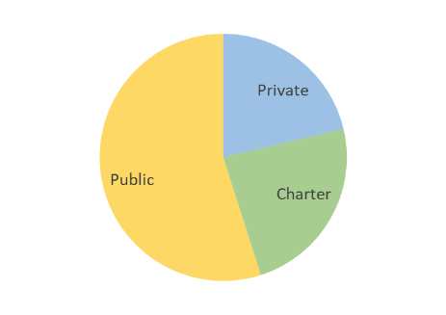

1. The top 3 zip codes for each school type are:

* Public – 63104, 63110, 63106
* Charter – 63118, 63103, 63139
* Private – 63108, 63109, 63110

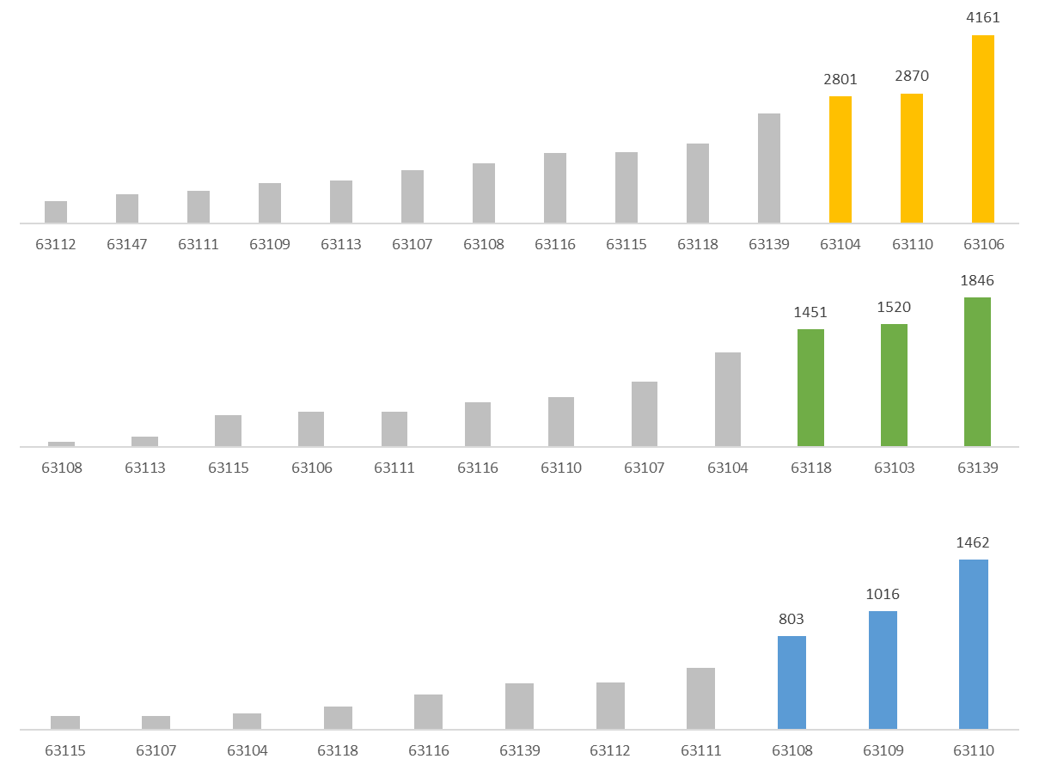

1. Over **38,000** students enrolled in St. Louis Charter, Private, & Public Schools.
2. Zips with highest enrollment:
   * 63110 (10 schools)
   * 63139 (14 schools)
   * 63106 (13 schools)
   * 63104 (18 schools)

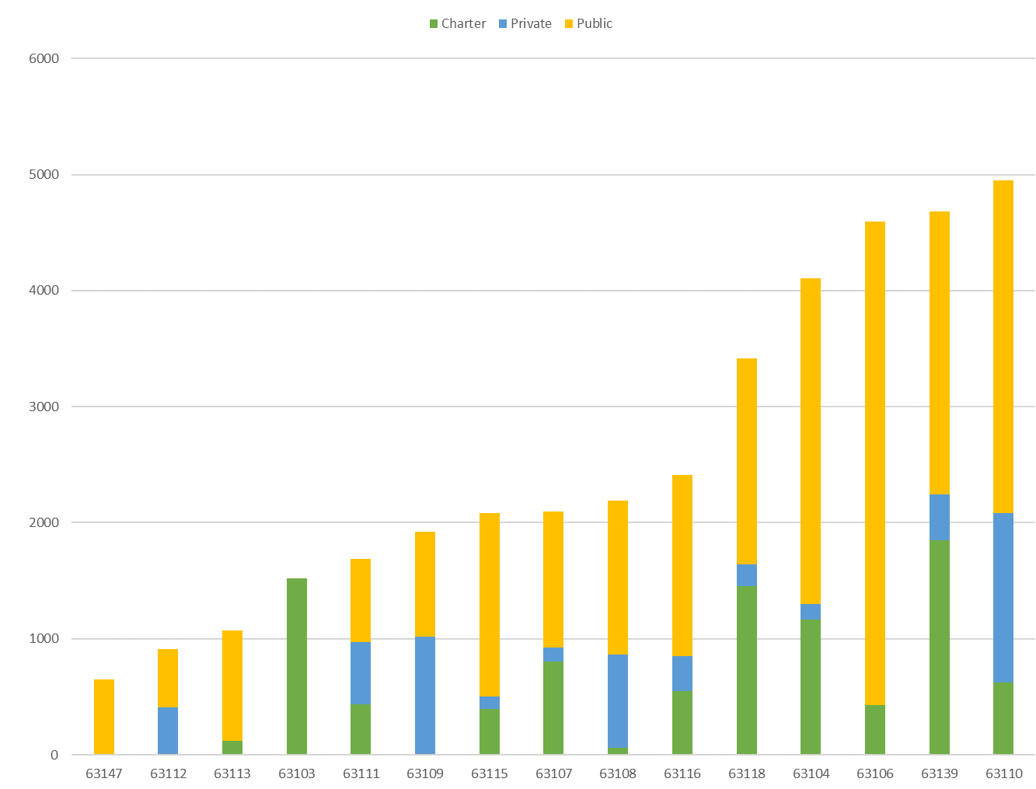

1. **Private Schools** report the lowest student to teacher ratios.

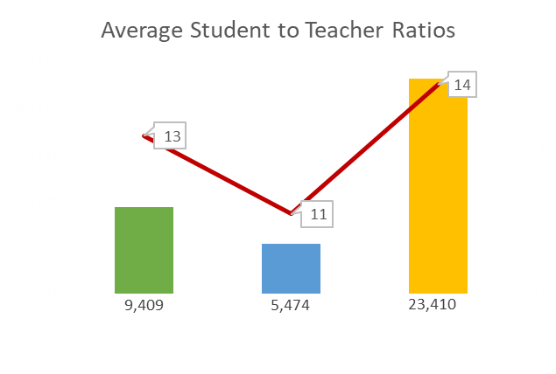

1. Zips with lowest student to teacher ratios:
   * **63103** (1,520 students)
   * **63108** (2,190 students)
   * **63104** (4,103 students)

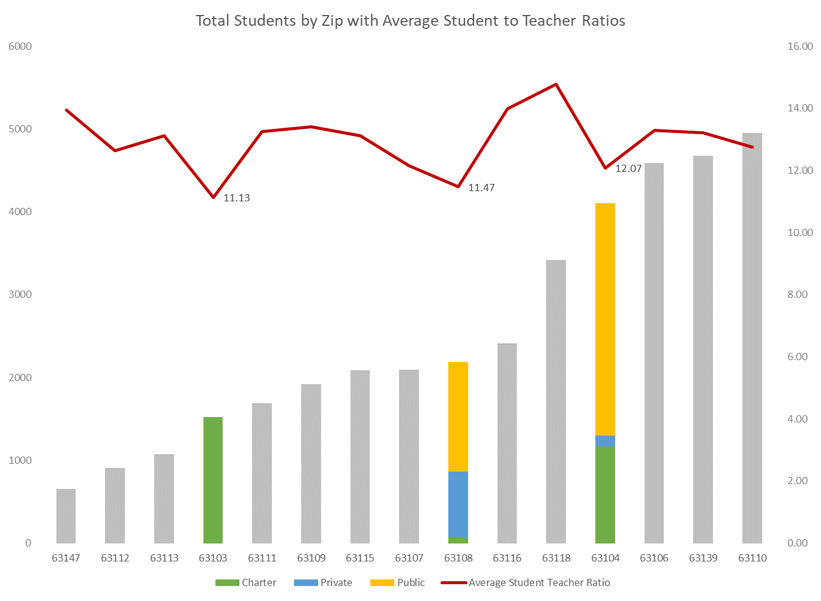

## Conclusions

1. Overall findings are:
   * No schools of any type identified in **63101** (Downtown) and **63102** (Riverfront and Gateway Arch).
   * **63109** is unique because more students are enrolled in private schools than public. No charter schools were identified in this zip code.
   * **63103** is unique because no students were enrolled in public or private schools. 100% of the students are enrolled in charter schools in this zip code.
   * **63147** is unique because no students were enrolled in charter or private schools. 100% of the students are enrolled in public schools in this zip code.

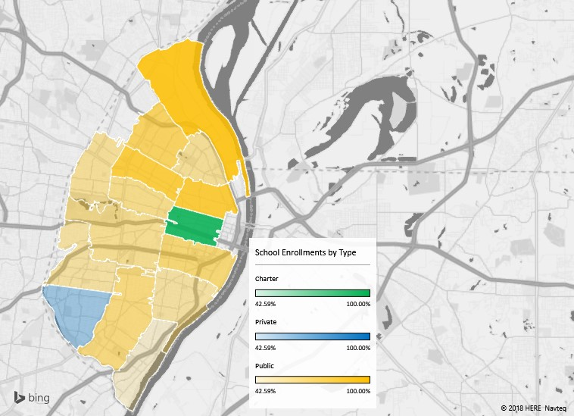

## Next Steps

Data was obtained from the Department of Elementary and Secondary Education (DESE) [website](http://mcds.dese.mo.gov/guidedinquiry/Pages/District-and-School-Information.aspx). Preliminary work was completed in [Jupyter Notebook](https://github.com/roricooper/Project-1-Personal-Repo-/blob/master/RC_Project%201%20Work/Jupyter_Notebook_Project1_Appendix/Rori_Cooper_Project1_Appendix.ipynb) using Pandas to create a Saint Louis Public School (SLPS) District Scorecard to showcase specific Building, Student, and Teacher statistics.

## Appendix

[ZIP CODE DIRECTORY FOR STREETS PARTIALLY WITHIN THE CITY OF ST. LOUIS](https://www.stlouis-mo.gov/government/departments/collector/documents/upload/33847-Zip-Code-Booklet-April-2018.pdf)

[Rori_Cooper_Project1_Appendix](https://github.com/roricooper/Project-1-Personal-Repo-/tree/master/RC_Project%201%20Work/Jupyter_Notebook_Project1_Appendix)